Goldenrod Data Sheet
Mobile Shaft Handling – SP 3000 & SP 3100

Goldenrod Contact:

Sales Representative:

Account Name |  | Phone:
Contact Name |  | Email:
Full Address:

Shaft Information
CRITICAL: Please include actual shaft drawing or dimensional sketch, pictures of shaft journals.
If journals are not identical – indicate which journal will be used for pick-up.

Shaft Overall Length: |  | Shaft Weight:
Shaft Body Length |  | Shaft Body Mat’l

Roll Information

Roll Sizes: | Max Diameter: |  | Max Width:
 | Min Diameter: |  | Min Width:

Application
Unwind or Rewind (circle)

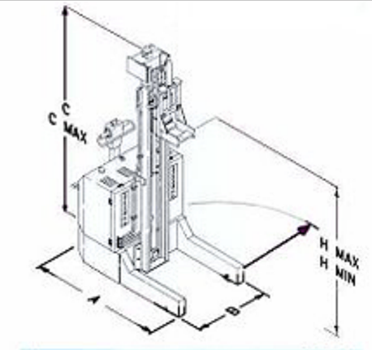 | Standard Dimensions | Change to: (Longer Lead-time)
 | A = 1280 mm / 50.4” | A =
 | B = 890 mm/ 35.05” | B =
 | C = 1750 mm/ 68.9” | C =
 | H Max = 2000 mm/ 78.75” | H Max =
 | H Min = 170 mm/ 6.7” | H Min =
 | Notes:

Shaft Inserted to Roll Core: |  | yes |  |  |  | no
Shaft Removed From Roll Core: |  | yes |  |  |  | no
Clearance for Legs: |  | yes |  |  |  | no
Floor Conditions: | Good: |  | yes |  |  | no
Any overhead issues/doorways: |  |  | no |  |  | no
Rev 1/24

